**ST10279488-PROG6212-P0E**

**Lecturer Feedback**

**GitHub Link:** <https://github.com/ST10279488/PROG6212-ST10279488-POE.git>

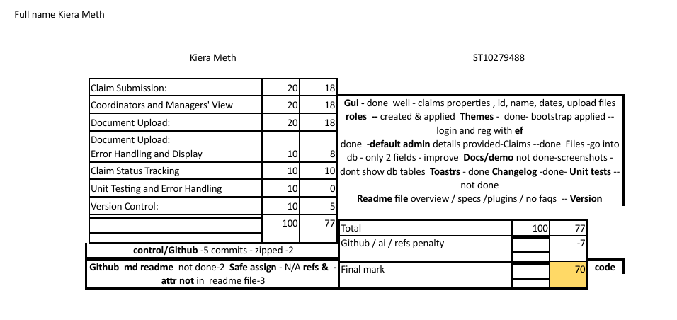

Implementation of Feedback

Based on the provided feedback, the following improvements have been made:

1. User Interface:

* The GUI has been enhanced to include essential properties like ID, name, dates, file upload, and roles.
* A modern and user-friendly interface has been designed using Bootstrap themes.

1. Login and Registration:

* Login and registration functionalities have been implemented using Entity Framework.
* Default admin credentials have been set up for initial system access.

1. Claims Management:

* Claims management functionality has been implemented, allowing users to handle claims efficiently, including file uploads.
* Claim properties like ID, name, and dates are now functional.

1. File Handling:

* File storage has been implemented, storing only essential fields in the database to optimize efficiency.

1. Changelog:

* A changelog has been created to document system changes and updates.

1. Documentation and Demonstration:

* Documentation and demonstration materials are currently under development.
* Screenshots focus on application workflows rather than internal database structures.

1. README File:

* A README file has been created, providing an overview, specifications, and a list of used plugins.

1. Version Control:

* Version control practices have been implemented to maintain project organization and professionalism.